|  |
| --- |
|  |

|  |
| --- |
| QUOTATION |
| 13 Days Vietnam | |
| Hanoi – Halong – Hue – Hoian – Saigon | |

|  |  |  |
| --- | --- | --- |
| Quotation for |  |  |
| Duration |  | 13 Days/ 12 Nights |
| Travel Period |  |  |
| Destinations |  | Vietnam |
| Tour Type |  | Private Leisure |
| Reference no. |  |  |

Itinerary

|  |  |  |
| --- | --- | --- |
| DAY 01 | Hanoi Arrival | (-, -, D) |

Welcome to *Hanoi*!!! As soon as the guests arrive at the airport, they will be assisted with their fast-track immigration process. Once they step out of the arrival hall, two Vietnamese ladies in traditional dresses will welcome them with some flower garlands and they will be warmly greeted by their tour escort. Afterwards the guests can enjoy the relaxing drive in a **Mercedes S 500** to the hotel, while our professional local tour escort will give them some first information about the city.

Check-in at the hotel and relaxation after the long flight. A Welcome package including a Vietnamese simcard, a traditional gift and a complementary bottle of wine will be placed in the room.

## Welcome Dinner at Ly Club Restaurant

*Ly Club offers a diverse selection of mouthwatering Vietnamese, Asian and European cuisine, deftly prepared by the executive chef to tempt even the most discerning palate*

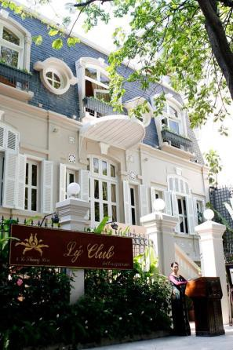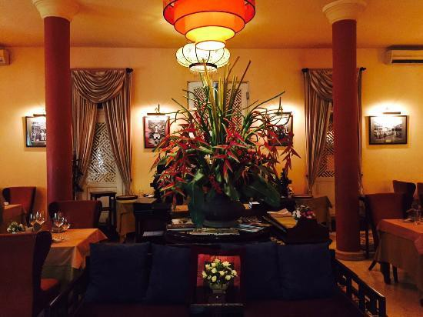

## Hotel: Sofitel Legend Metropole Hanoi (Grand Premium Opera Wing)

## Overnight in Hanoi

|  |  |  |
| --- | --- | --- |
| DAY 02 | Hanoi Exploration | (B, L, D) |

Breakfast at the Hotel. Pick up by the Tour escort for an exciting **Jeep Tour around the city**

Hanoi is perfect for an urban adventure with its ancient history, a colonial legacy and a modern outlook. Our Jeep will carry you passing by colonial legacy preserved in French architecture, lakes, parks, shady boulevards and century-old temples. Discover the remote parts of Hanoi that the normal tourists rarely visit and at the same time take the chance to visit any of the typical landmarks that are of interest to you.

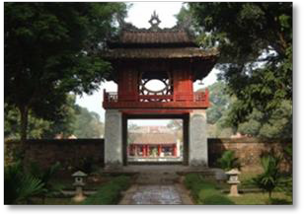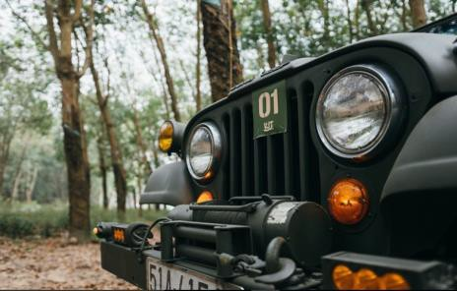

You are free to choose one of the highlight destinations of Hanoi you would love to explore from the list which is highly recommended by our professional tour escort. Then, a drive around the West Lake and small streets will bring you lot of fun and chances to capture the daily routines of local people from the Jeep. The next stops in this trip are Hoang Hoa Tham Street and the former French Quarter.

Hoang Hoa Tham Street is well known as one of the three traditional markets for flowers and ornamental trees with an eye-catching display of colorful and beautiful flowers.

In between you will have a break at a local tea or coffee house to enjoy Vietnamese traditional tea…

**Lunch at Madam Hien Restaurant**

*Located right inside the heart of Hanoi, Madame Hien is a French antique building designed by the chief architect of the renowned Hanoi Opera House. The restaurant is also the latest venture of the most celebrated French chef in Vietnam – Didier Corlou.*

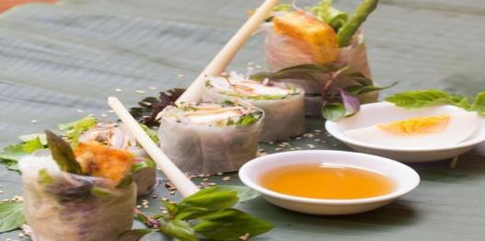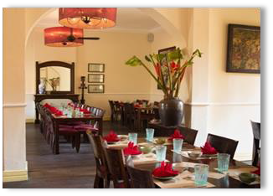

After lunch continue the tour by a visit of the **Museum of Ethnology.**

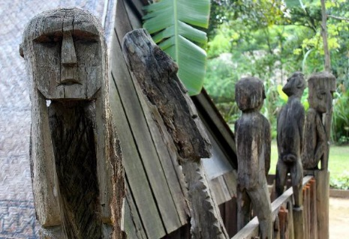

During a private gudied tour by a famouse Vietnamese ethnologist, the Ethnology Museum in Hanoi gives an excellent overview of the country’s ethnic groups, their customs and ways of life. The highlight here is the large, beautiful outdoor area featuring genuine houses and compounds as built and used by the many different ethnic groups.

## Dinner at Club L’Oriental Restaurant

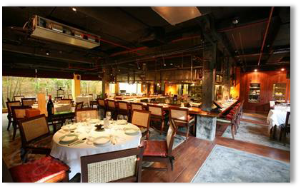

*Club L’Oriental Restaurant located in the backstreets near the Opera House and Metropole Hotel is one of the most luxury Vietnamese restaurants in Hanoi . The menu of the restaurant comprises of Vietnam’s best tastes and offers the highest quality of food and service.*

## Hotel: Sofitel Legend Metropole Hanoi (Grand Premium Opera Wing)

## Overnight in Hanoi

|  |  |  |
| --- | --- | --- |
| DAY 03 | Hanoi - Halong | (B, L,D) |

After breakfast transfer to Hanoi’s airport to take a **private seaplane** (with flexible time) to Halong (Flight time 1 hour including 15 minutes scenic flight)

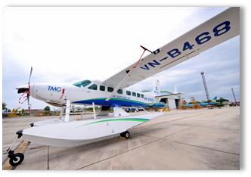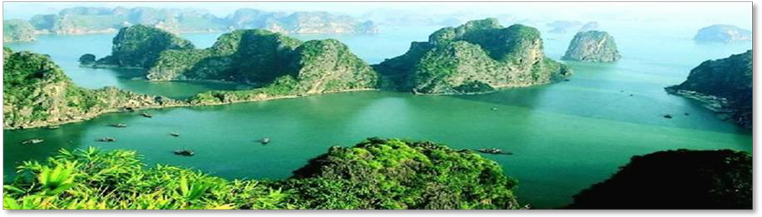

About 170km (105 miles) from Hanoi, Halong Bay is one of the most magnificent scenic spots in all of Vietnam and was recognized as a world natural heritage site by UNESCO in 1994.

You will get the chance to explore the picturesque bay with almost 2,000 islets rising from the clear emerald waters of the Gulf of Tonkin during a **luxury 2 Day/ 1 Night cruise**

**Program 2 days/ 1 night – subject to change without notice**

11.30: **Check-in at Paradise Suites Hotel - Tuan Chau Island**  
On arrival at Paradise Lounge after the long drive from Hanoi, you will have time to refresh yourself before boarding time

12:30: **Embark on Paradise Peak**

Once you have embarked, you will be taken to the restaurant where you’ll meet the Paradise Peak crew. While you enjoy your welcome drink, you will be given a short briefing about your cruise and itinerary. Don’t forget - your butler will take care of your every need while you are on board.

13:00 **Lunch in the restaurant**

Lunch will be served in the restaurant while cruising the islands and islets of stunning Halong Bay.

14:00: **Cruise Halong Bay or enjoy a Spa Treatment**

After lunch is the time to contemplate the timeless beauty of Halong Bay as Paradise Peak cruises past the limestone islands, islets and towers. Alternatively, you may wish to use this time for a spa treatment at **Le Parfum Spa**\*

14:45 **Visit Tung Sau Pearl Farm or kayak**

Your first excursion is a visit to Tung Sau Pearl Farm, an area in Halong Bay dedicated to growing pearls and practicing a handmade technique based on Vietnamese tradition and Japanese technology. This is also an ideal destination for kayaking. If this excursion doesn’t take your fancy, stay on board and treat yourself to a delicious afternoon tea.

16:15 **Visit to Sung Sot Cave**

Your next stop is the magnificent Sung Sot Cave. The cave itself is stunning but so are the views on exit, where you’ll be rewarded with sweeping views across the Bay

18:00 **Pre-Dinner Sunset Cocktails* and Cooking Demonstration**

The Paradise Peak will anchor overnight at Coconut Tree Island. Indulge in a cocktail or two during Pre-Dinner Sunset Cocktails* as you watch the sunset from the sundeck, followed by a demonstration of easy-to-make Vietnamese recipes

19:30 **Royal Bao Dai Dinner**

Enjoy your Paradise Royal Dinner your way - dine anywhere you want on the ship: your cabin, the sundeck or the restaurant. It really is up to you. After dinner, the rest of the evening is yours to enjoy: squid fishing, a movie in your cabin, more drinks* on the sundeck or even a spa treatment at**Le Parfum Spa**\*

## Cruise: Paradise Peak Cruise

Note: The Paradise Luxury cruise itinerary may change from time to time depending on the weather forecast or the instructions given by the Halong Bay Management Authorities

*payable at own cost

## Overnight on board

|  |  |  |
| --- | --- | --- |
| DAY 04 | Halong - Hanoi | (B, L,D) |

06:30 **Tai Chi on Sundeck**

Awaken your senses with a Tai Chi session on the sundeck before breakfast. Breathe in the fresh morning air, watch the sunrise and feel your body revitalise.

07:30 **Visit to Titov Island**  
Paradise Peak arrives at “must see” Titov Island. Hike to the top for stunning views of Halong Bay, or go for a refreshing swim in the cool, emerald waters. For a morrelaxing visit, you can people-watch while sipping on a coconut.

08:30 **Breakfast in the restaurant**  
Back on board, breakfast will be served in the restaurant or in your cabin as we cruise past Thien Cung and Dau Go Caves and Fighting Cocks Islet. Bill settlement and check-out before we return to Tuan Chau Island.

10:30 **Disembark at the Tuan Chau Marina**

11:00 **Your private car/bus is waiting for the transfer back to Hanoi**

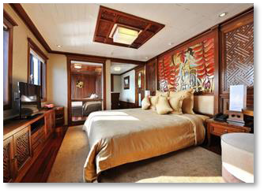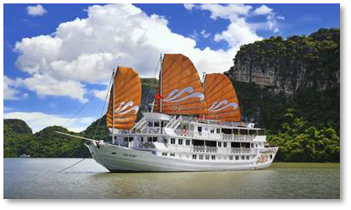

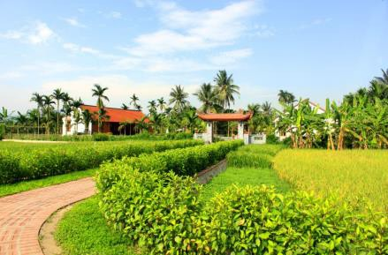On the way back to Hanoi, the clients will stop at **Yen Duc Village** to enjoy a water puppet show & lunch.

The beautiful village is part of a community based tourism project ideally located on the way between Hanoi and Halong Bay and offers a glimpse of village life & an authentic cultural experience. Admire the charming fields, the amazing tranquility in Yen Duc village.

Visit a farming garden and a local family house. Meet and talk with the friendly villagers and get an understanding of local life and family tradition. Pass through the fields to visit the culture house of the village with its views of poetry inspiring scenery. Enjoy an amazing water puppet show in the village fields, presented by village artists.

After the lunch & private water puppet show, continue to Hanoi. You will arrive Hanoi in the late afternoon.

## Dinner at Press Club Restaurant – Michelin Menu Table du Chef

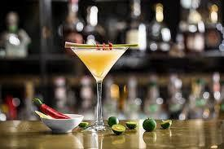

*Set in its original colonial décor from the 1920's, La Table du Chef is a subtle journey into fine crafts, paintings, culinary and winemaking arts. Lovers of haute cuisine are invited to hunt for traces left by the hand gestures embedded into many aspects of the decoration of the restaurant.*

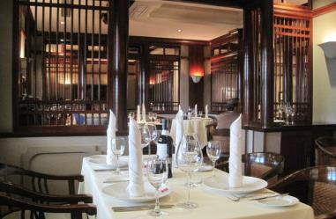

*Here, in the splendid surroundings of old colonial flair, you can experience a unique 2 Michelin-star menu from Alain Dutournier (Paris) and enjoy the best cocktails in town from the world championship finalist mixologist – Mr. Pham Tien Tiep.*

## Hotel: Sofitel Legend Metropole Hanoi (Grand Premium Opera Wing)

## Overnight in Hanoi

|  |  |  |
| --- | --- | --- |
| DAY 05 | Hanoi - Hue | (B, L,D) |

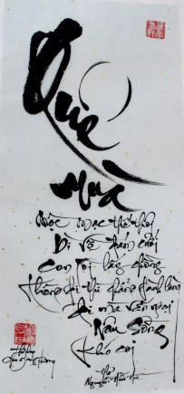After breakfast get a lesson in the art of Vietnamese calligraphy.

Traditional Vietnamese calligraphy is strongly affected by that of China for historical and geographic regions. In modern times, calligraphy has been done mainly in the Latin-based Quốc Ngữ script, as Chữ nôm and Chinese characters have largely fallen out of use. Quốc Ngữ calligraphy gained popularity during the New Poetry and Free Poetry Movements due to the increasing popularity of using the Vietnamese vernacular, as well as influence from French literature.

Even when education was restricted to scholars and elites in Vietnam many years ago, calligraphy played an important part in Vietnamese life. On special occasions such as the Lunar New Year, people would go to the village teacher or scholar to make them a calligraphy hanging (often poetry, folk sayings or even single words). People who could not read or write also often commissioned scholars to write prayers which they would burn at temple shrines

## Lunch at Home Restaurant

*The fusion of old world splendour and cutting edge sophistication defines Home – Vietnamese Restaurant. Here the finest traditional Vietnamese food partners with inspired contemporary cuisine, presented with warm service and in spectacular surroundings.*

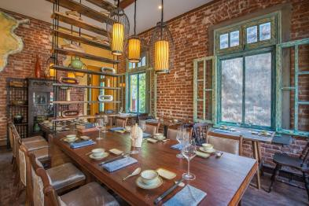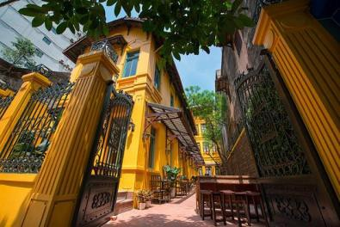

Transfer to airport for the flight to Hue. Arrive in Hue. Pick up and transfer to the hotel

**Hue** – the ancient capital of Vietnam, is a city full of green trees with a peaceful atmosphere, quiet but equally busy, and crowded. The city has preserved the tombs, temples, palaces and many beautiful gardens of the Nguyen Dynasty that wait to be discovered.

## Dinner at Ancient Hue Restaurant

*The Nguyen emperors' banquets were legendary, with some feasts said to have included 300 rare dishes served in more than a thousand bowls. To satisfy the nobles' craving for variety, Hue's royal cooks specialized in small, bite-sized morsels, developing delectable appetizers and snack foods unique to this region. Trained at a five star hotel, Ancient Hue's chef mixes those local specialties with Asian and European flavours to create memorable modern-day royal feasts for the guests.*

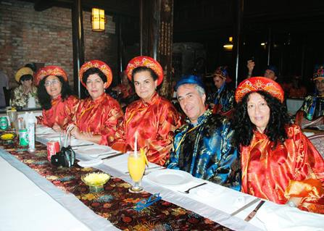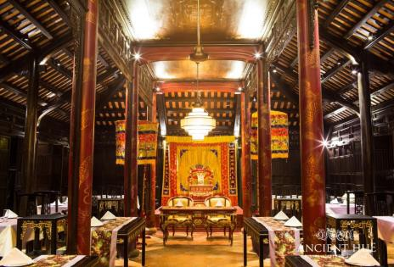

## Hotel: La Residence Hue (Colonial Suite)

|  |  |  |
| --- | --- | --- |
| DAY 06 | Hue - Hoian | (B, L,D) |

After breakfast enjoy a **half-day city Tour of Hue.**

First visit **Thien Mu Pagoda**. The Pagoda has two sections. The front of the Pagoda houses the seven-storey octagonal Phuoc Duyen tower, which has become the symbol of Hue. The other section of the pagoda is its rear portion, where the monks of the temple live and practice Buddhism.

Afterwards visit **the Citadel at the Imperial Palace.** It was completed in 1833 and from here the emperors of the Nguyen Dynasty ruled Vietnam till 1945. A one hour cyclo ride will be included in the journey around the Citadel which reminds many visitors of the forbiddencity in Bejing.

Your trip to Hue will be completed by a visit to **the tomb of Khai Dinh**, Emperor of Vietnam from 1916 to 1925. The tomb represents a fusion of traditional Vietnamese style and modern influence. The construction of the tomb began in 1920 and lasted 11 years. On the way back to your hotel you stop at a village that is well-known for its production of typical Vietnamese conical hats.

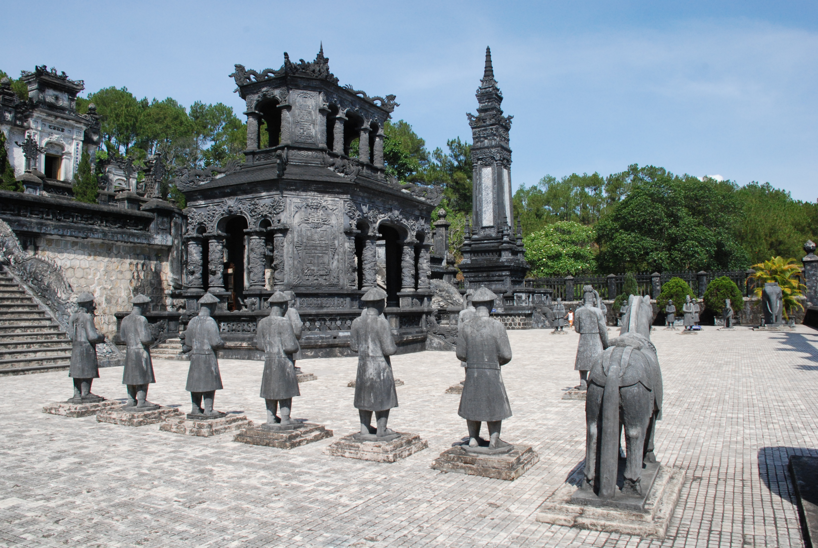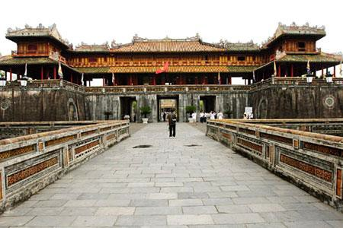

## Lunch with Meditation at the Cat Tuong Quan Zen House

*Surrounded by pine hills and magnificent gardens, Cat Tuong Quan Zen House was designed based on ancient Feng Shui principles and serves as a perfect environment for a spiritual and organic food experience. Guests can experience the distinctive and delicious vegetarian dishes and beverages created from freshly organic herbs and herbs and products grown in the complex, combined with some spiritual retreat and a walking meditation after the lunch.*

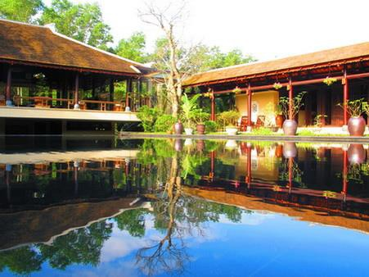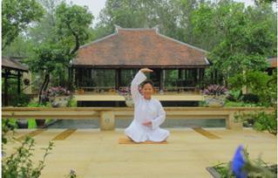

Transfer to Hoi An via the Hai Van Pass. In Vietnamese “Hai Van pass” means the pass of ocean clouds. It is located on Highway 1 between Danang and Hue and enables you to admire a spectacular stretch of scenery where mountains seem to fall into the sea.

Check-In and Dinner at the Hotel.

## Hotel: Four Seasons The Nam Hai (One Bedroom Pool Villa)

|  |  |  |
| --- | --- | --- |
| DAY 07 | Leisure Day | (B,L,D) |

Today guests chose between various optional activities or simply relax at the pool/ beach of the resort and enjoy its different amenities.

## Option 1: Golf

The Resort is within a 10-minute drive of two championship golf courses: the 18-hole, 7,116-yard Montgomerie Links Golf Course, designed by Colin Montgomerie; and the 18-hole, 7,176-yard The Dunes at The Danang Golf Club, designed by Greg Norman

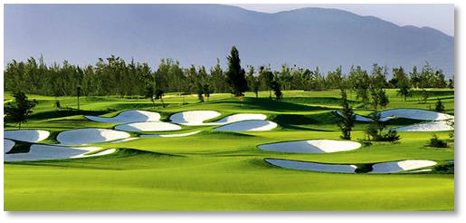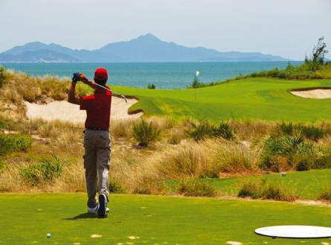

## Option 2: The Heart of the Earth Spa

In a beautiful setting perched over a lotus pond, The Heart of the Earth Spa is a haven of calm, connection and compassion. Inspired by renowned Vietnamese Zen master, scholar and peacemaker Thich Nhat Hanh, the Spa centres on the awareness that we are not separate from the Earth but at one with her, and that by aligning with nature’s rhythms, we can improve harmony within ourselves and between humanity and the planet.

All treatments feature crystal singing bowls tuned to 432 Hz. – the harmonic intonation of nature

– plus simple focused breathing techniques to attune body and mind to the Earth’s heartbeat.

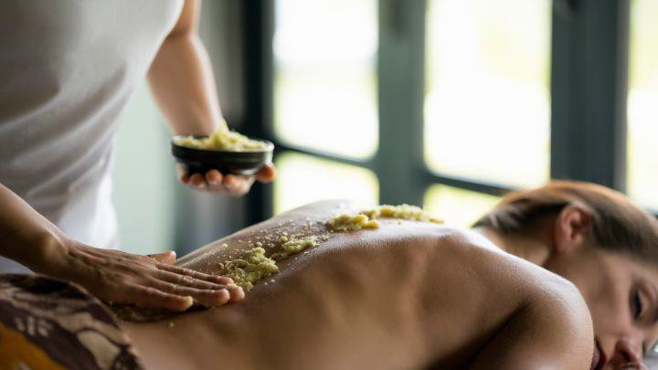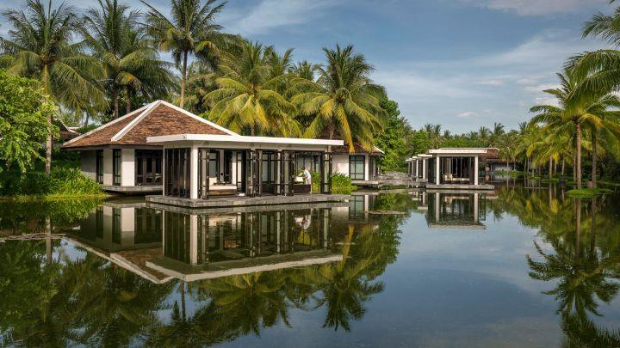

## Option 3: Morning Vespa Tour around Hoi Ans Country Side (lunch included)

Setting off from Café Zoom in Hoi An, we ride over the bridge to Cam Kim island into the beautiful rural countryside, riding along the river, then stopping off at an Ancestral House and a traditional boat builders yard (seasonal) before we set off to explore the sleepy island villages. Zig-zagging through the breath-taking scenery of rice paddies and farmland, taking stops along the way to learn from friendly local families the art of mat weaving, farming and how to make (and eat) the perfect “banh dap” (rice cracker). After our snack, we ride out riverside to cross a spectacular & adrenalin pumping 300 metre long bamboo bridge to the opposing landscape of the seaboard side of the island. We make our way to the coast at the Thu Bon river mouth, along roads lined with Casuarina pine & cashew nut trees. Riding into a small village, we stop at a local café to fuel up on local drip-coffee & learn the art of coffee roasting. Then, it's up high and over the new bridge offering spectacular panoramic views of Hoi An, which takes us to the water coconut palm fringed Cam Thanh and then on to a sensational seafood lunch on Hoi An’s glorious beaches.

Tour includes: Vespas, drivers, tour guide, all entry fees, cold water, drinks & snacks at designated stops, seafood lunch at beach.

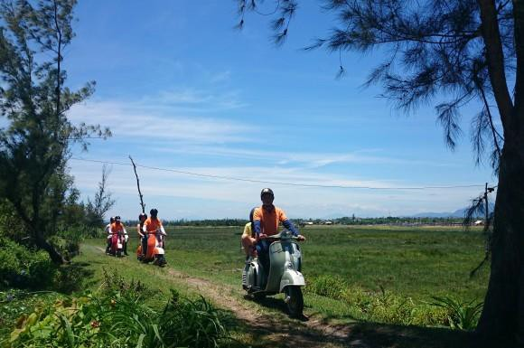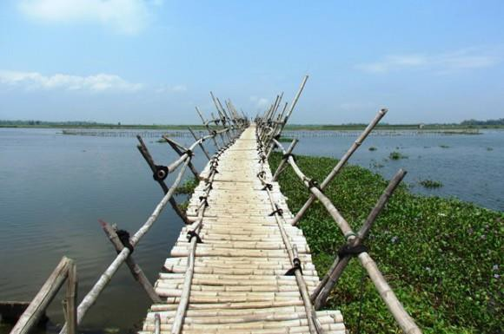

## Dinner on a bamboo raft in Hoi An

*For today’s unique dining experience a bamboo raft will be placed on the surface of the Co Co river bank near the Field Restaurant. Guests can enjoy the countryside environment and truly special atmosphere while they will be served with fresh food and daily catch from the surrounding river.*

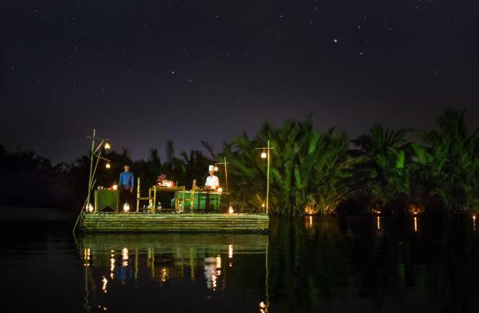

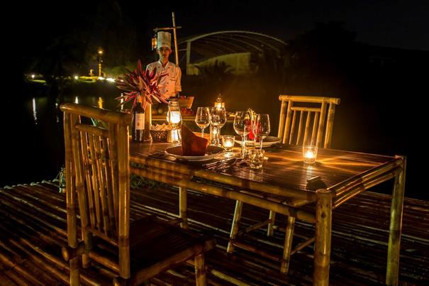

## Hotel: Four Seasons The Nam Hai (One Bedroom Pool Villa)

|  |  |  |
| --- | --- | --- |
| DAY 08 | Hoian Cultural Country Life | (B, L,D) |

Today the **Hoi An Cultural Country Life Experience** provides you with a close-up and intimate exposure to both the local farming and fishing communities.

Accompanied by your tour guide, you commence the day leisurely cycling along country roads (shuttle service available for those who cant cycle) witnessing local Vietnamese rural life first hand, discovering all manner of photo opportunities - coming and visiting a beautiful organic vegetable village, watering and planting vegetable, hoeing a soil with local farmer, riding a water buffalo in a rice paddy field; seeing ducks swimming along the rice farm or farmers tending their crops. The photo opportunities are endless. As well you will experience the friendliness of the local people greeting you along the way. After lunch with a local family and a short therapist foot massage you will board on private boat for a river cruise to meet and engage with local fishermen and enjoy a hands-on experience of traditional net fishing. You will also experience paddling the unique Vietnamese bamboo basket boat while the waterways of coconut palm paradise. This tour provides you with a cultural window into the ways of life of both our farming and fishing communities.

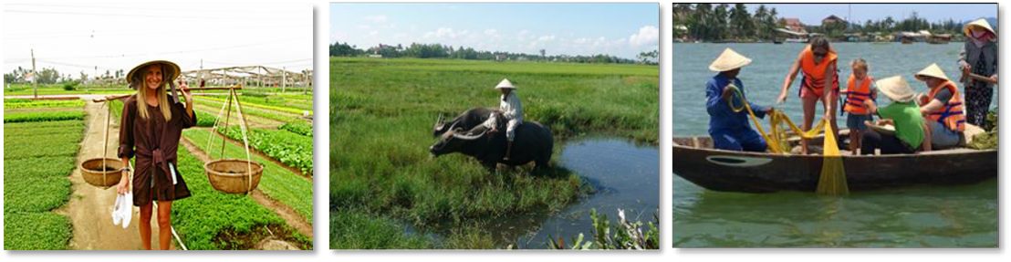

In the Afternoon **exploring Hoi An on foot** is one of the best ways to take in the city’s charm. While discovering the small yet beautiful town, tourists and frequent visitors alike find that it is a place of quiet and peace. The unique atmosphere here combines elements of Vietnamese, Chinese and Japanese culture. Some of the most remarkable views of the city are from the ancient houses. From here, visitors can catch a glimpse of a long gone past and more subdued and simple time.

The tour includes visits to Hoi An Museum, many of the town’s renowned Ancient Houses which boast remarkable architecture, Assembly Halls of Chinese influence, a handicraft workshop and of course the must-see Japanese Covered Bridge.

An optional stop is at the private home of Diep Dong Nguyen (subject to availability) to view a stunning collection of pottery, seals and old Hoi An photographs.

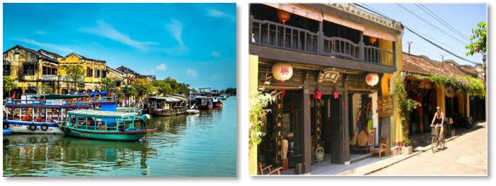

## Dinner at The Vy’s Market

*If you’re looking for a unique culinary experience, where you will gain an understanding of how ingredients are selected and assembled to create local dishes, then Ms Vy’s Market Restaurant is the perfect venue. As with all of Ms Vy’s culinary ventures the key purpose of Vy’s Market Restaurant is to give customers a sensory food experience unlike any other.*

*In Vietnam, a town’s market represents not just a place of commerce, but a meeting point for catching up, gossiping and, of course, eating – it is at the pulse of all community activity.*

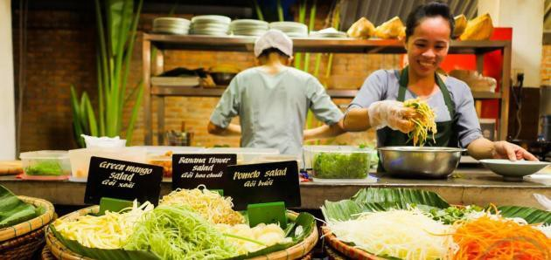

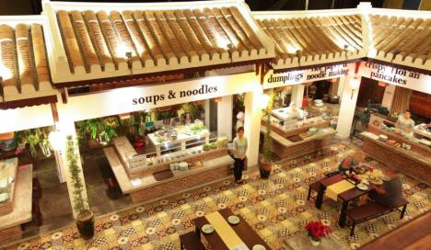

## Hotel: Four Seasons The Nam Hai (One Bedroom Pool Villa)

|  |  |  |
| --- | --- | --- |
| DAY 09 | Hoian – Danang - Saigon | (B, L,D) |

After breakfast transfer to Danang airport for the flight to Saigon. Upon arrival your private car

& guide will welcome you at the airport and transfer you to the selected hotel.

## Lunch at Di Mai Restaurant

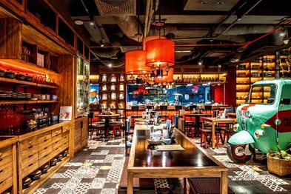*Set in the heart of bustling Ho Chi Minh City, Di Mai (translated “Aunty Mai”) offers diners a respite from the hectic streets of Vietnam, transporting them into a whole new world, where vintage-nostalgia meets modernity. Crafted from traditional recipes from all over Vietnam, Di Mai features a well-curated menu that blends local Street Food with home-style cooking, which will leave you craving more.*

Afterwards enjoy a **traditional music performance at Truc Mai House.**

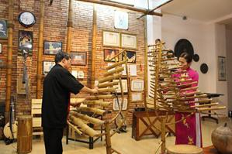Arrive at Truc Mai House (at a pre-arranged time) where you will be welcomed with a cup of tea. You are at the home of Mrs. Tuyet Mai and Mr. Dinh Linh, who have both studied at the Vietnam National Academy of Music. They are long time experts of traditional music and have been representatives of Vietnam performing in countries around the world. Their house is a warm, inviting space where they perform sharing their passion entertaining guests with traditional Vietnamese music. Vietnamese musical instruments, though very simple, are quite interesting and attractive to overseas people for their sound and unique characteristics. Enjoy a short show! After the show, you’ll have the opportunity to play any and all of the many traditional instruments yourself amidst kind coaching and laughter from your hosts!

## Evening Saigon City tour by Citroen Vintage car

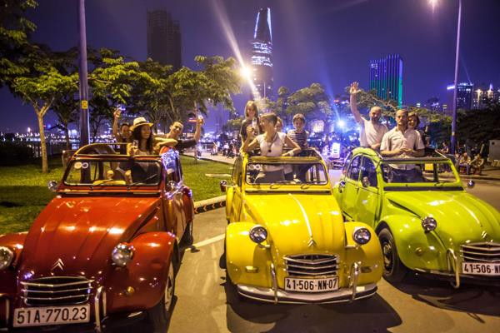After an intense day of meetings, negotiations or conferences, nothing beats the timeless charm of vintage French cars to explore Saigon. Several stops will be made at unique landmarks, off the beaten tracks restaurants and sightseeing spots along the way.

Treat your most valued collaborators to very original experience on board the most authentic and legendary French car in history. Aboard our Citroen 2CV ( and its cousin the La Dalat) guests will drive into the mysterious heart of Saigon by night. Saigon is a bustling and restless city in constant evolution. Energy and chaos are its main features and that is what makes it attractive. In this legendary Citroen car, visitors will discover or rediscover this multi-faceted Saigon, its unsung neighborhoods, colonial vestiges and secret busy streets.

This tour has a special touch which offers a truly unique experience: the sound of the car engine, the convertible top that offers a panoramic view of the city the quaint comfort of the rear seats and the bouncing effect of the legendary suspensions of the 2 CV… An unforgettable experience.

From the city's major landmarks to hidden lanes and unexpected places, guests will definitely get out of the usual hackneyed neighborhoods while having the opportunity to taste delicious "street food" along the way . This tour starting in the early evening offers a striking overview of the city and lots of great memories.

## Hotel: Park Hyatt (Park Deluxe Room)

|  |  |  |
| --- | --- | --- |
| DAY 10 | Saigon Exploration | (B,L,D) |

Breakfast at Hotel.

In the afternoon enjoy a **private cooking class at Grain Cooking Studio by Luke Nguyen** (subject to his availability)

Luke Nguyen is a renowned Australian chef of Vietnamese origin and is recognized as a food expert professional all around the world with his restaurants and cooking shows broadcasted internationally, in England, USA and all around Asia. Luke designs the GRAIN menus and recipes, selects his team of cooks and instructors as well as cooking facilities and equipment.

During the private classes guests can pick and choose from the seasonal Grain Menus, which dishes they want to cook and create their own personalized cooking class!

So Grain is actually not a run-of-the-mill cooking class, but in essence, a Vietnamese culinary experience. It aims to inspire and excite one's palate to the vast array of delicate and aromatic flavours that make up Vietnamese cuisine.

In addition to learning the fundamentals of food preparation and presentation, guests can expect to experience a glimpse of Vietnamese history and hands-on approach allows guests to select and choose their own produce, herbs, spices, and sauces, with the hopes of instilling confidence in their own abilities to create a beautiful 3-course meal from start to finish.

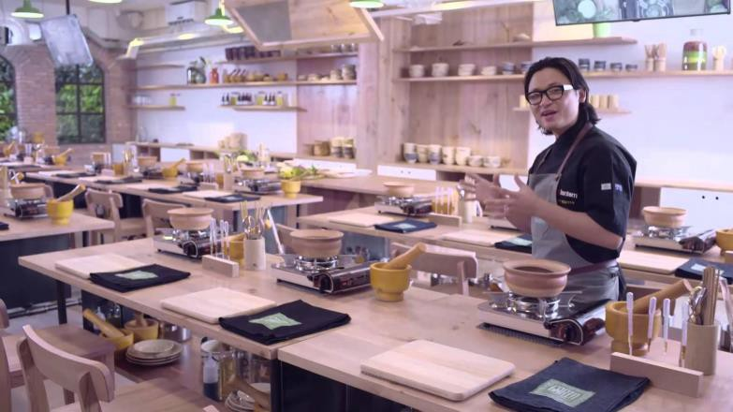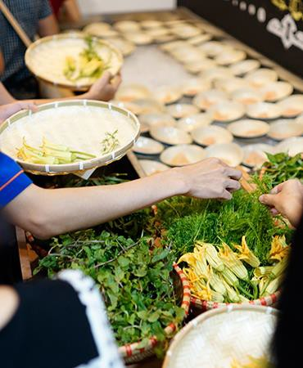Hotel: Park Hyatt (Park Deluxe Room)

|  |  |  |
| --- | --- | --- |
| DAY 11 | Saigon Cu Chi Tunnel Visit | (B,L,D) |

08:00am depart to the Cu Chi Tunnels by Speed Boat

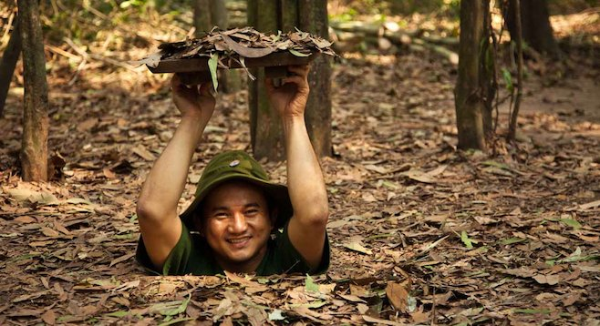**Cu Chi Tunnel** Complex – a national symbol of Vietnamese courage!

Cu Chi was an important base during the American War, because of its strategic location. The Vietcong built a 200km long network of tunnels connecting command posts, hospitals, shelter and weapon factories.

Dug out of hard laterite by hand tools without the use of cement, the tunnel system stretched from Saigon to the Cambodian border and was three levels deep.

Today, the remaining tunnels have become a major tourist attraction, giving visitors a unique experience and a feeling of what underground life in the war must have been like.

## Lunch at the Deck Restaurant

The Deck is situated on the banks of the Saigon River, a short 15 minute journey from the heart of Ho Chi Minh City. Saigon's only modern restaurant Pan Asian cuisine where friendships, romance and fine food comes together. Once you’ve been greeted by a smile, enjoy the breeze, unwind with a signature cocktail and savour the contemporary menu.

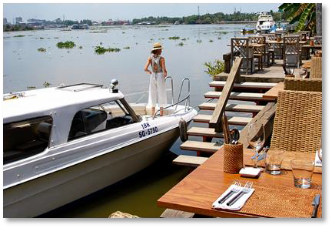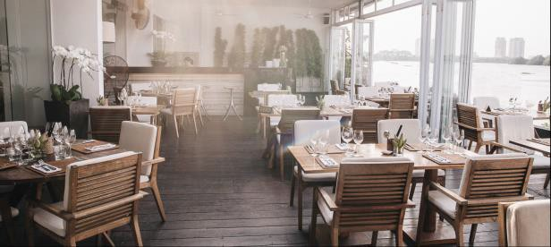

**Evening AO Show at the Opera House**

Experience the richness of Vietnamese culture with this spectacular hour-long show mixing the acrobatics of contemporary circus with the theatricality of the stage, the musicality of a moon string instrument, and, above all, poetry. The leading visuals of the show – the chastity of bamboo, the basket boat – reflect the spirit of the Vietnamese people and their heritage.

There is no script, no climax and no sequence. During the hour-long show, the audience is gently introduced to many different tones of emotion of Vietnamese life, capturing in it the Vietnamese dream of life, love, and everything in between

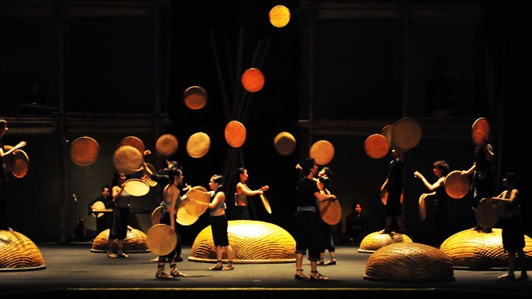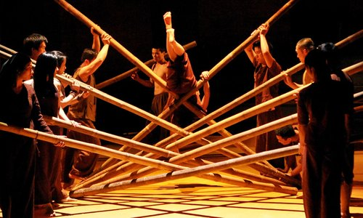

## Dinner at Sorae Restaurant

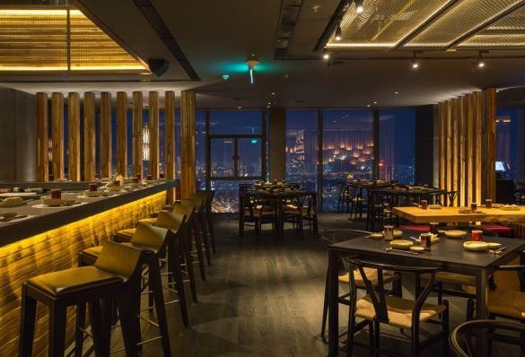

“Sorae”- Up in the sky , is one of the most spectacular restaurants in the city and a “must go” destination at the heart of the bustling busy district of Saigon.Situated on the 24th & 25th floor of AB tower overlooking magnificent panoramic views of Ho Chi Minh City, eating and dining are taken to an exciting new level at Sorae, where its fellow diners can experience a unique, authentic Japanese serving culture and heritage at the highest Japanese restaurant in HCM city.

## Hotel: Park Hyatt (Park Deluxe Room)

|  |  |  |
| --- | --- | --- |
| DAY 12 | Saigon – Mekong Delta - Saigon | (B,L,D) |

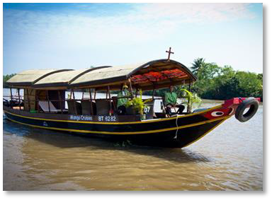At 8.00am, depart for a 1.5 hour drive from Saigon to Ben Tre, one of the country's southern provinces, situated in the Delta of the Mekong River. Take in the highway as you leave behind the busy city. Pass Rach Mieu bridge before reaching Huu Dinh hamlet. Get on a tri-motor cycle (xe loi) ride to enjoy the lush surroundings of rice paddies and fruit farms alongside the narrow village roads. Arrive at the waterfront, board the charming Mango Cruise for a glimpse at the Delta scenery while enjoying coconut juice. Make a first stop at a small brick workshop where the locals still use centuries-old traditional methods to make the bricks by hand.

Then you will head back to your boat to cross the An Hoa River, where you will start a Bicycle trip around Phong Nam village (around 4km). On the way stop for a visit at the local house where they live on coconuts processing. Continue the bike ride through gardens and stop at the a rice noodles factory “hu tieu”, one of most popular breakfast dishes in the region. Walk about 3 minutes to visit at Mrs. Huong’s home. Her family lives from fishing shrimps and farming. Enjoy some tropical fruits and honey tea in her garden before you move on to your rowing sampan.Your personalized rowers already await you and take you on a trip to discover the maze of small canals in the Mekong Delta.

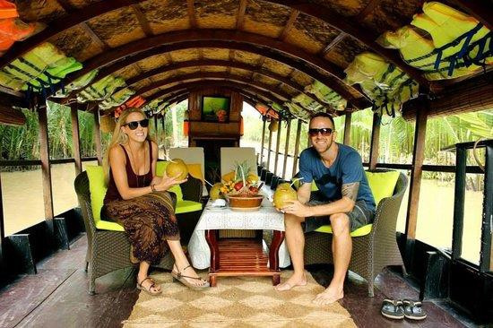

After rowing you back to the mango boat, you will head to Mango home restaurant. Here you will enjoy your 5 course lunch and freshen up before you switch to a bicycle again and ride 500m (about 4 minutes / or 7-10 minutes walk) on village roads past green gardens and local houses. Then stop at the local house of Mr Sau Tuong, a former Vietcong soldier who survived two years fighting the Khmer Rouge in Phnom Penh.

Now he and his wife live on making rice paper which is the most famous specialty of My Long village. Have a chat with him, enjoy the crispy rice paper made by his wife, and see how it is made.

After the visit, the boat will be waiting for you at the pier nearby to bring you back to Ben Tre city where your car will be ready to take you back to Saigon.

## Dinner at Hoa Tuc Restaurant

*Making great use of a historical location, Saigon’s old opium refinery, Hoa Tuc was built, designed and furnished locally with custom made wrought iron furniture, cast iron lamps and pergolas. Staying clear from “fusion”, the chef established a menu to wow the senses and gave Saigon its first Contemporary Vietnamese Cuisine restaurant in August 2008*

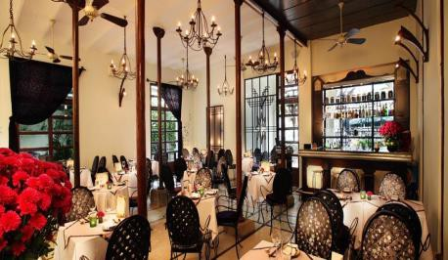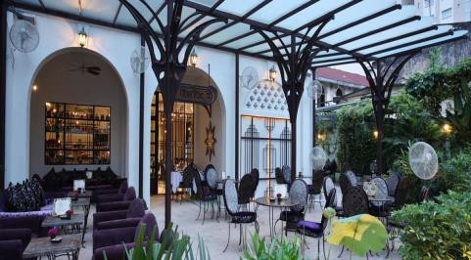

## Hotel: Park Hyatt (Park Deluxe Room)

|  |  |  |
| --- | --- | --- |
| DAY 13 | Saigon Departure | (B,-,-) |

Breakfast at Hotel

Free time at leisure until transfer to airport for your departure flight.

|  |
| --- |
| End of services |